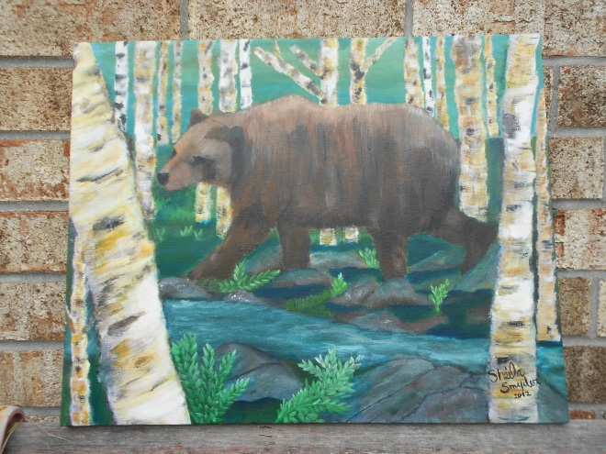
`
Among many things, nature is by far a great inspiration, beautifully colored leaves of fall, raindrops falling into puddles of rain, fluffy white clouds. Nature is beautiful—as an artist it is my greatest inspiration.

What is the relationship among nature, art and society? To me nature is beautifully created, for every season there is change in nature and it creates it-self, how amazing is that? Art is created by the artist, it is what they vision, the artist creates. Society in its own way, creates what they want to see. John Berger, an established influential art and cultural critic, also a publisher of a number of books and essays on art criticism, explores the relationship among nature, art, and society using peasant art, in his essay “The White Bird”. He has been asked from time to time to speak on aesthetics. What is aesthetics, you ask? It is the philosophy of the nature of art, the appreciation of beauty.

On one occasion he is asked to speak on aesthetics and thought he would take a bird made of white wood, but he didn’t go. He states “you can’t talk about aesthetics without talking about the principals of hope and the existence of evil”. The white bird is a small intricate handcrafted bird that is made of white wood, and you hang it in your house, it is considered “peasant art” because it is handmade with intricate skill by the artist. He states that “it would be absurd to compare one of these birds to a van Gogh self –portrait or a Rembrandt crucifixion”. As an artist I personally appreciate all art, whether it be a famous painting, or a handcrafted bird. So I have to ask where is he going with this?
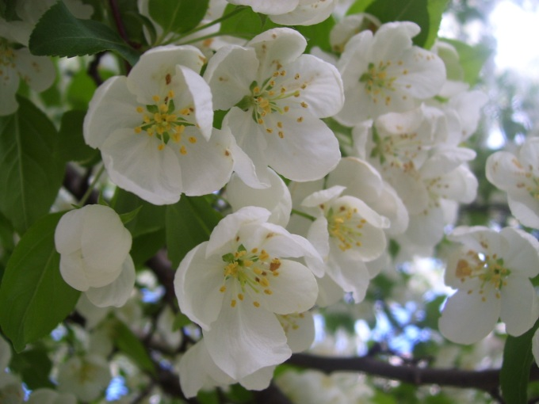
He starts with, being asked to speak about aesthetics, refuses, and starts talking about the white bird and how it’s made, he is comparing art to nature and the aesthetic emotion involved. An aesthetic response to what is real and what is not. The white bird is a creation made by man which makes it not real, and in nature--outside the bird is very real. Nature, by itself is created. In other words if we see either one we respond to it with some emotion. So in comparing nature to art, and society, we all look at the same thing but we have different reactions, depending on a lot of our beliefs, our geography, our history, etc.
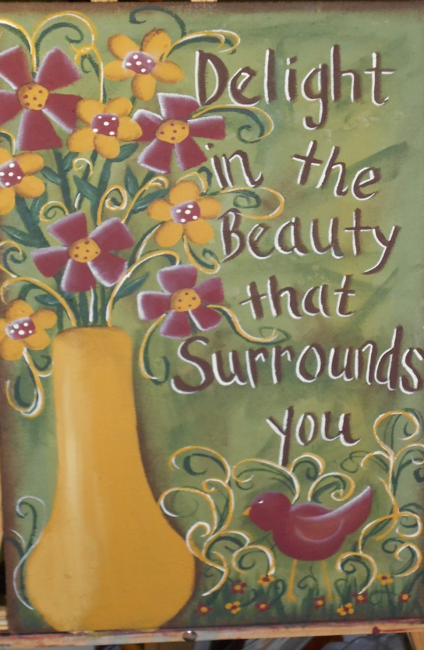
Though some contrast and some confusion at first, I believe he has a good point. It is a very interesting article and gives the reader something to think about. What are we really looking at?

“Art does not imitate nature, it imitates a creation, sometimes to propose an alternative world”.

Written By: Sheila Snyder

