ARTIST…

INTRODUCTION

Hello my name is Sheila Snyder, I am a self-taught artist. I’m also a single mother of 5 children, ranging in ages 4-29, and I have 5 grandbabies. My life is what most people call me, CRAZY!! I started painting on my own when I was 27, and just had my 3rd child. After successfully selling my crafts at craft shows I knew this was my gift. I continued painting and painting and painting. Divorced after 19 years in an emotionally and sometimes physically abusive relationship, I was finally free to find myself, and on that journey I took a few wrong turns…because I was so controlled by my husband, it was like being set free from your parents for the first time and I felt like I was just 18 starting my life over, although I was already 38. I didn’t have the means to really continue painting…that was put off for a while, and in the meantime had two more children, two more bad relationships, and now 10 years later am going to school to get an art degree and I am painting again.

Every child is an artist. The problem is how to remain an artist once we grow up. ~Pablo Picasso
***********

What’s in a name?

New Beginnings Decorative Painting and Designs by Sheila
That is what I named my new business, because it was a new
beginning for me. After all I’d been through I knew I still wanted to
paint.

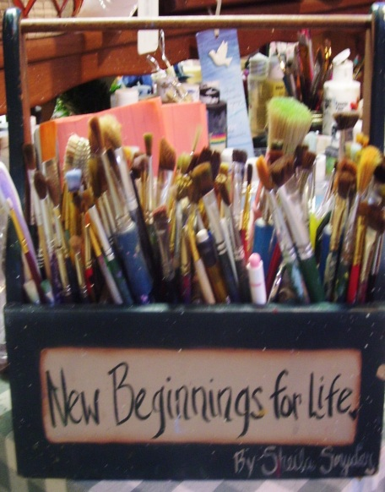
Everything in creation has its appointed painter or poet and remains in bondage like the princess in the fairy tale 'til its appropriate liberator comes to set it free. ~Ralph Waldo Emerson

I believe that God gave me a second chance, that I had been set free from bondage, and I take this opportunity to put color in peoples lives, to put a smile on someone’s face, to bring warmth to a cold world.

*************

My Work…or Play

Painting is my passion, whether it’s on canvas, on a wall, or old things I pick up and up-cycle. Painting to me is like breathing, I love to put the paintbrush in my hand and ask God “What are we painting today”? He always has an answer…People tell me all the time that I surely have a Gift from God. I couldn’t agree more.

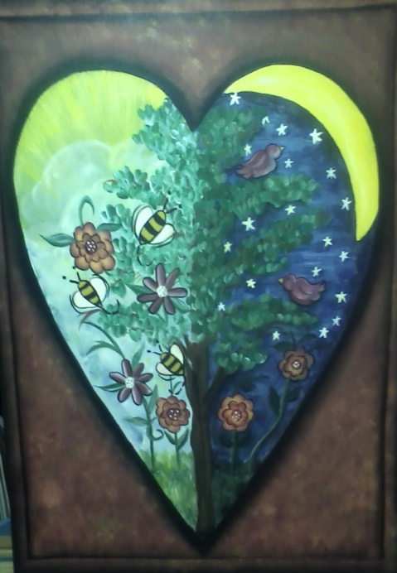
This piece is named “The Birds and the Bees”. The story behind this order is, the customer’s grandma always sang this song to her and she wanted me to paint something with that theme in mind. This is what I came up with and needless to say she loved it.

************

My Job

By the grace of God I currently work for the Alma Housing Commission, I am their artist, annual picnic coordinator for decorations and theme, I am in charge of decorating the interior of the buildings, and coordinate and teach craft classes for the residents. I love my job!!

Men’s Restroom 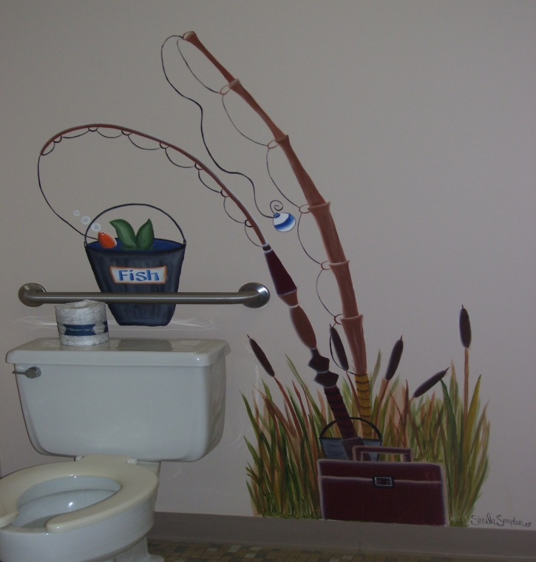 Laundry Room

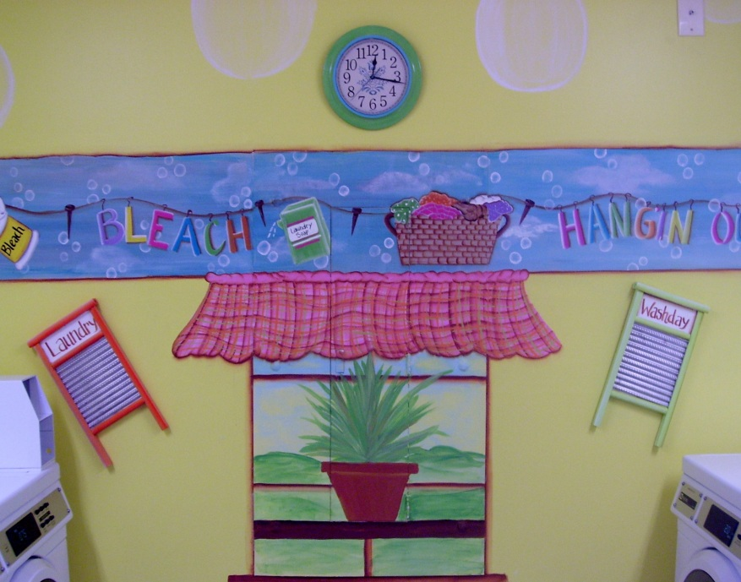

Craft Class Annual Picnic

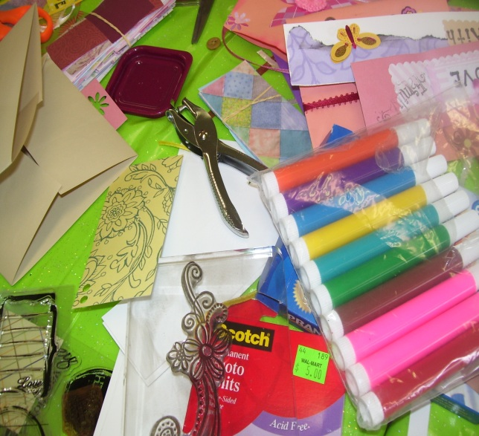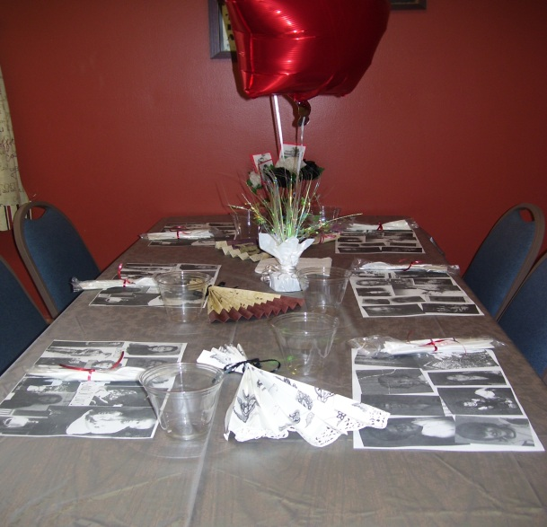

Decorative painting is a lot of fun--I enjoy painting on walls, whether it’s a mural or a border. It takes me an average of 10-15 hours to do a wall, depending on how much detail I do.

************

FACEBOOK

http://www.facebook.com/pages/New-Beginnings-Decorative-Painting-and-Designs-by-Sheila/139079536153073?ref=hl
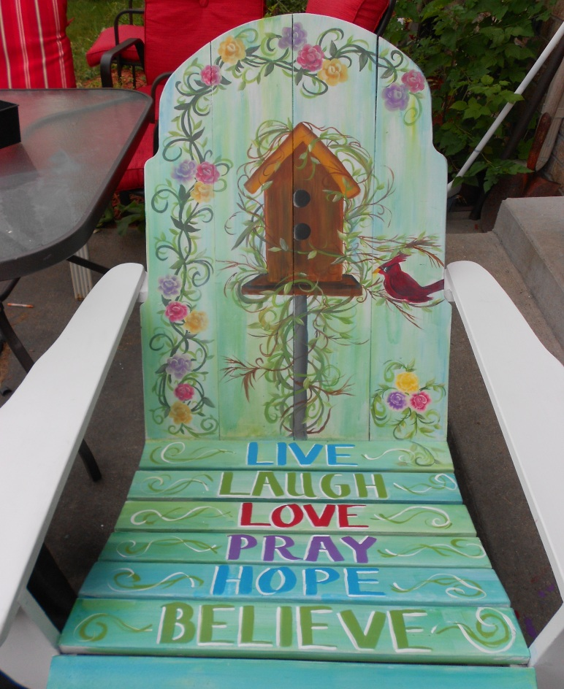
Facebook is a great marketing tool for me, I have what you call a
business page. I set it up according to my business and I post pictures of what I’ve done. I put some of my work on there that is for sale…but I usually will get special orders. Along with advertising it is a great encourager for me.

************
Weebly
http://newbeginningsdecorativepaintings.weebly.com/index.html

Weebly is a place on the web where you can design your own website. I just recently started doing this, it’s a lot of work but well worth it for advertising. You can see my web site by clicking the link above. There you will find all my work by slideshow, you just pick the category from the top of my home page of what you would like to see and you’ll be watching a slideshow of what you are interested in seeing.

************

Murals

Murals are what we artist call…. anything painted on a wall that is large. I love painting murals, it’s a lot fun for me to paint on walls…you have this big canvas to do what you want with. I have done quit a few of these. Unfortunately I don’t have many pictures of the ones I did years back. I’ve done Character Counts in two schools, a gas station at youth center, I’ve done a lot of nurseries, and children’s rooms. I even painted someone’s shed door. This is a picture of what I am currently working on…..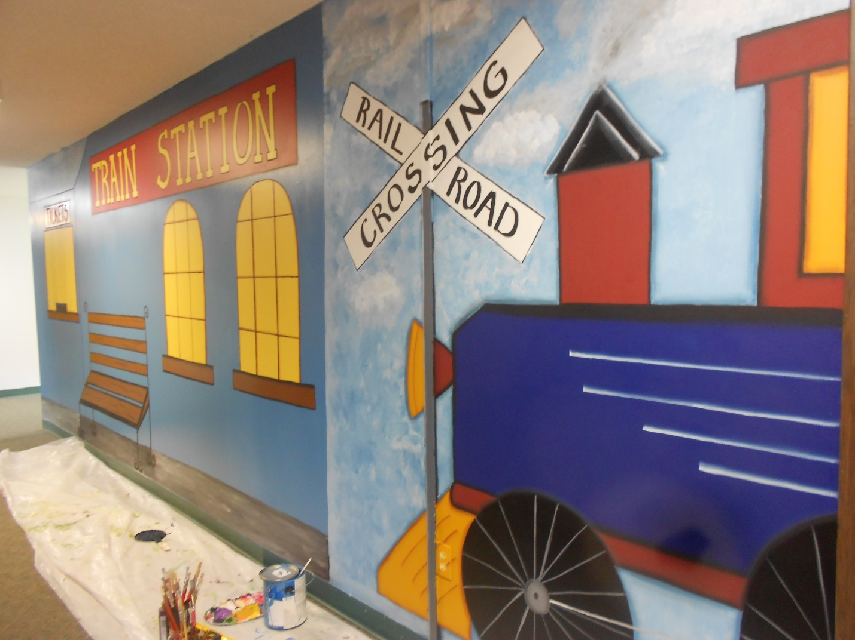
I got hired to paint a village in a church, this is a huge project there are going to be 9 different rooms. This is the “The Train Station”.

************

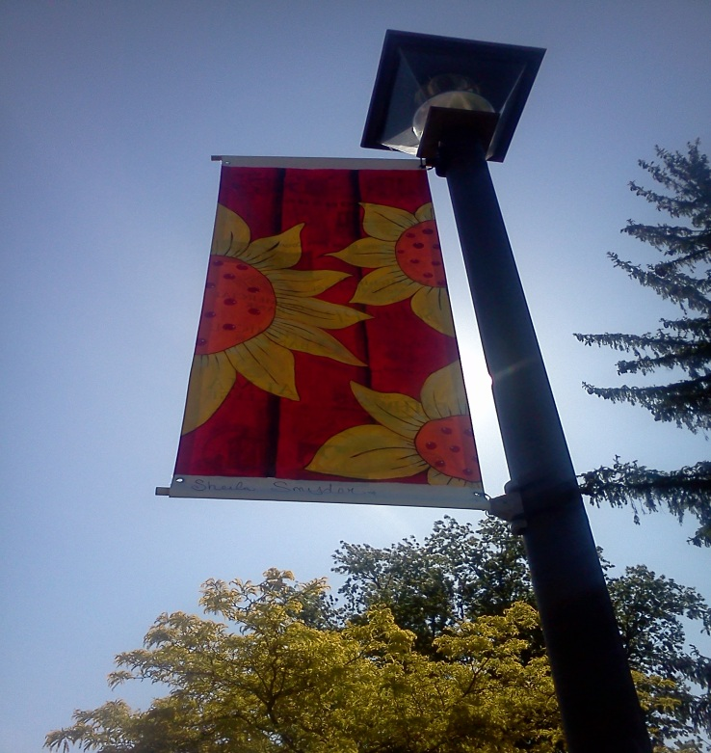
MY BANNER I entered a contest with the Gratiot Downtown Art Expo, to design a banner that would hang in downtown Alma. I had to design it on paper with colored pencils. I chose a painting I did in my painting I class, I chose this design because it was bright and happy. My design got chosen, I then went to Art Ventures, in Alma and got to paint the banner, and now it is hanging in the downtown area. I was so happy to have been able to participate in this project

************ SCHOOL

My decision to go to college was based on the fact that I wanted to learn more about art and learn how to market my work. I am in my 3rd semester and I love it. I am attending MMCC in Mt. Pleasant, Mi. and am going for a Visual Arts Degree. At this point I don’t know if I will continue on for a Bachelors Degree, I’m just taking one step at a time.
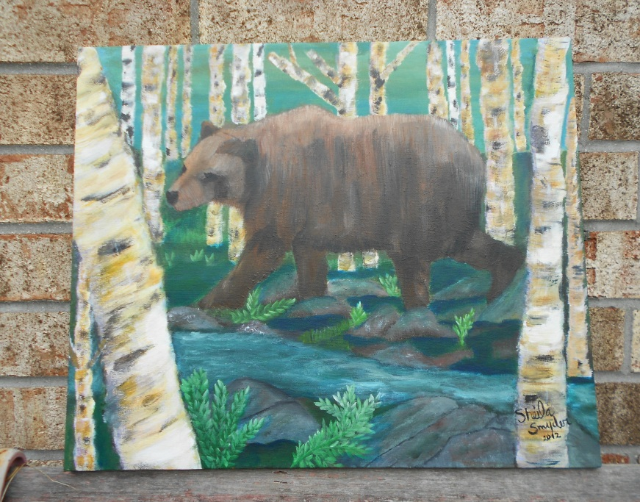

Painting1. Final Painting

This was my final painting in class. We had the option to paint whatever we wanted, I chose to go out of my box, and paint something I wouldn’t normally paint. . I finished this class with an A, and I learned so much.

************

Life beats down and crushes the soul and art reminds you that you have one. ~Stella Adler

************

Artist…
Though I’ve had a rough start in life, I am blessed, I am able to continue painting, learning more, and raising my beautiful children in a positive, and encouraging life. I love my work…I love my children….and I love life!!

